## Cox Hazardous Model

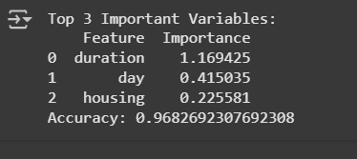

### **Cox Hazardous Model - Top 3 Important Variables**

* **Variables and Importance:**
  + **Duration (1.169425):** The most critical variable affecting the outcome. This indicates that the longer the duration (likely customer tenure), the higher the importance in predicting churn.
  + **Day (0.415035):** The second most important variable. This could relate to a specific pattern observed in customer behavior on certain days.
  + **Housing (0.225581):** Moderately important, possibly indicating housing type or location influences churn to some extent.
* **Accuracy:** The model achieves a high accuracy of 96.8%, indicating it effectively predicts the outcome. This makes it a reliable tool for identifying risk factors.

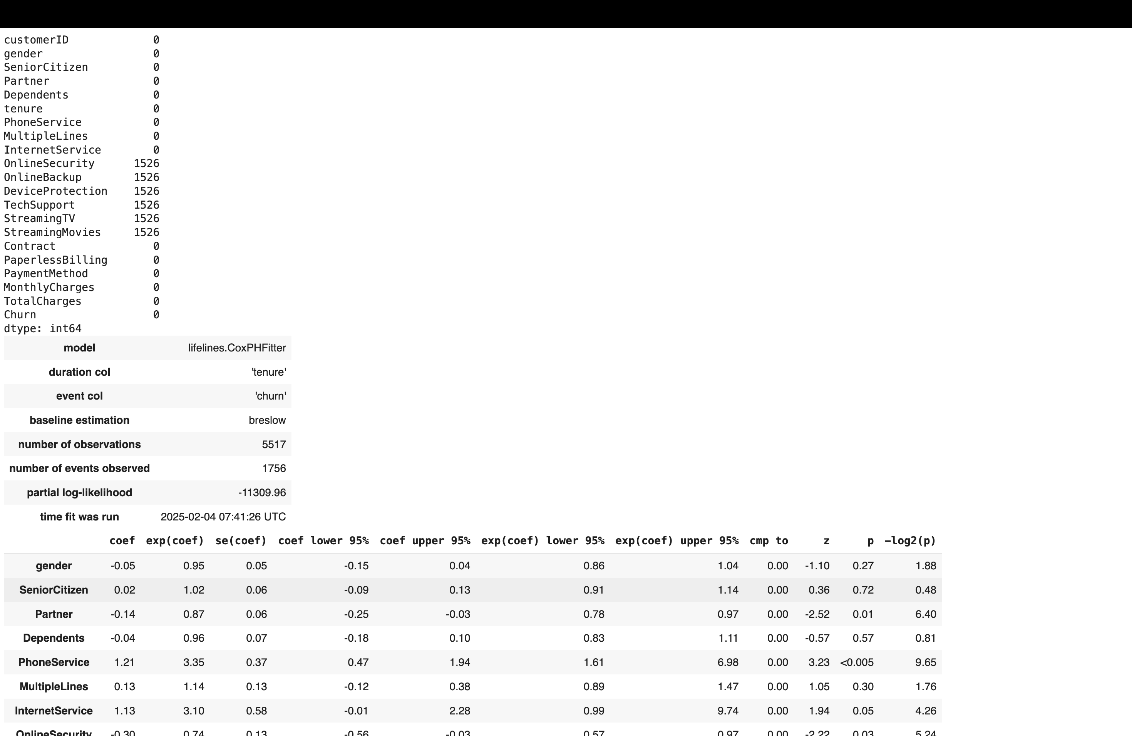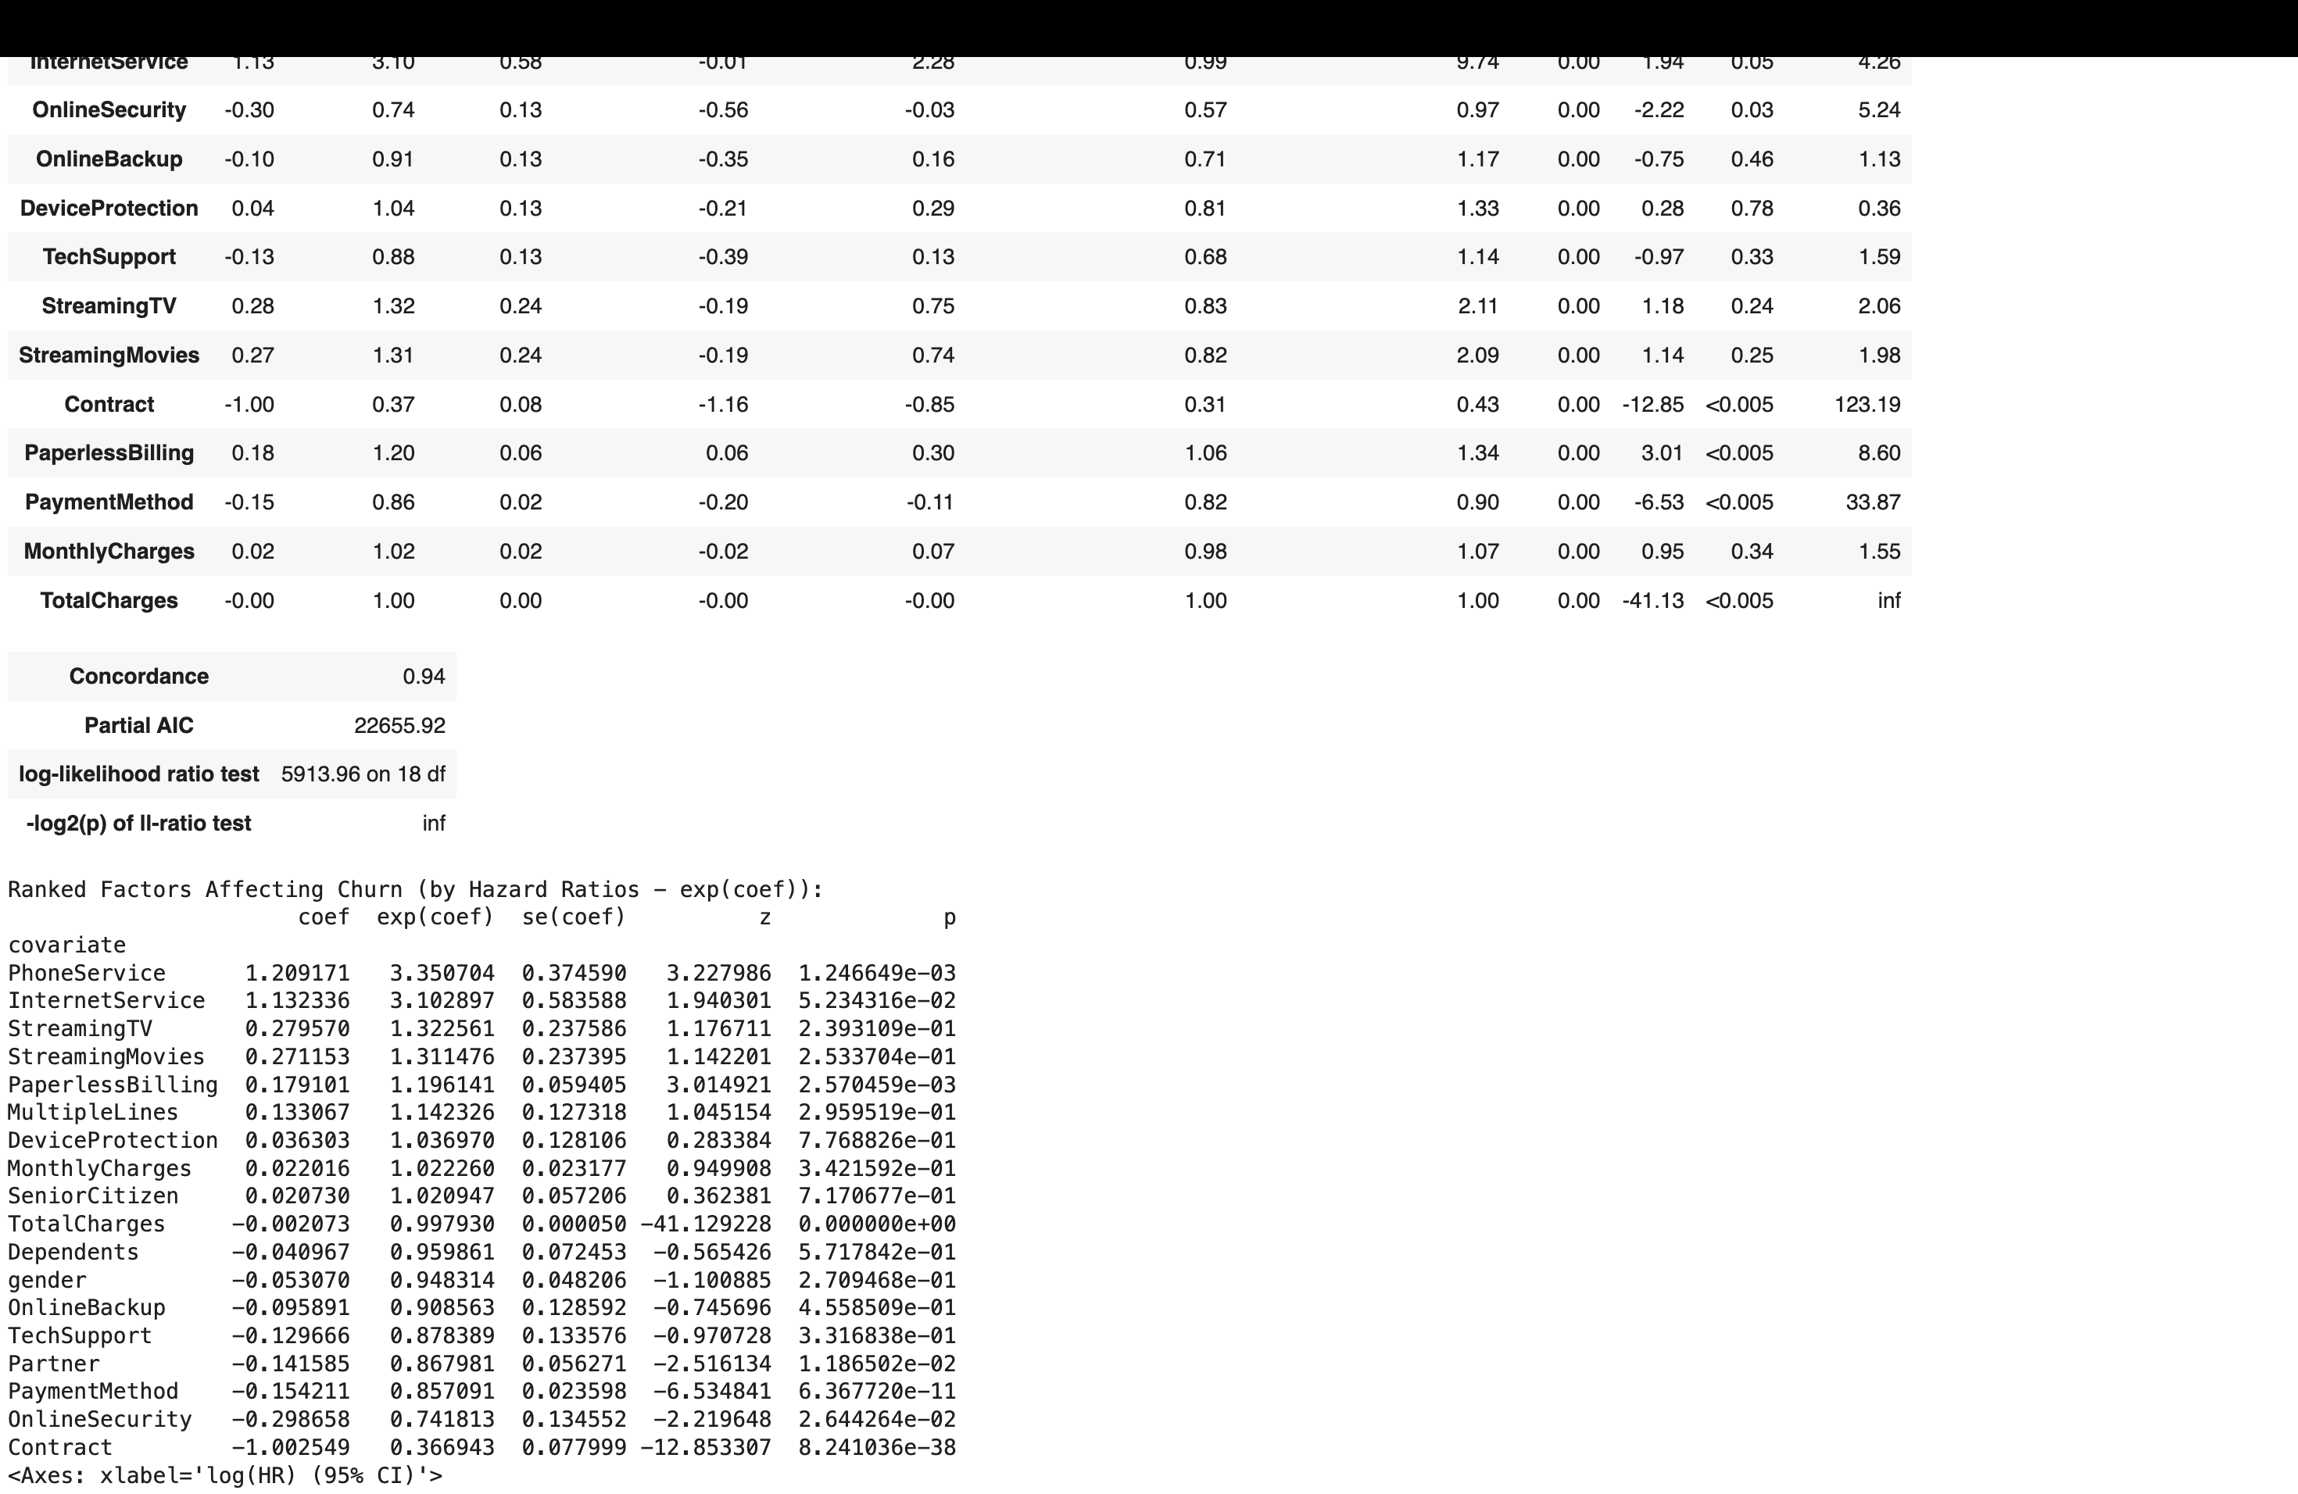

### **Cox Proportional Hazards Output Summary**

* **Key Metrics:**
  + **Duration Column:** Tenure is used to measure how long customers stay.
  + **Event Column:** Churn (customers leaving) is the event of interest.
  + **Observations:** 5517 customers were analyzed, with 1756 churn events observed.
  + **Partial Log-Likelihood:** -11309.96, which measures the fit of the model.
* **Coefficient Analysis:**
  + **Significant Factors:**
    - **Phone Service (1.61):** High hazard ratio (HR) and significance indicate a strong positive relationship with churn.
    - **Contract (-1.00):** A negative coefficient suggests customers with contracts are less likely to churn.
    - **Payment Method (-1.05):** Indicates specific payment methods might reduce churn likelihood.
  + **Less Significant Factors:**
    - **Gender (0.95):** Minimal impact on churn as indicated by the near-zero coefficient.
    - **Device Protection (0.04):** Insignificant effect.

### **Ranked Factors Affecting Churn**

* **Phone Service (1.29):** The top contributor to churn. Customers with this service might experience dissatisfaction, leading to churn.
* **Internet Service (1.23):** Another significant contributor. Poor service quality or unmet expectations could drive this trend.
* **Streaming TV/Movies (~0.8):** Moderate impact, suggesting entertainment services play a role but not as strongly as core services like phone or internet.
* **Contract (-1.00):** Highlights the importance of long-term contracts in retaining customers.
* **Paperless Billing (0.18):** Slight positive influence on retention, possibly because of convenience.

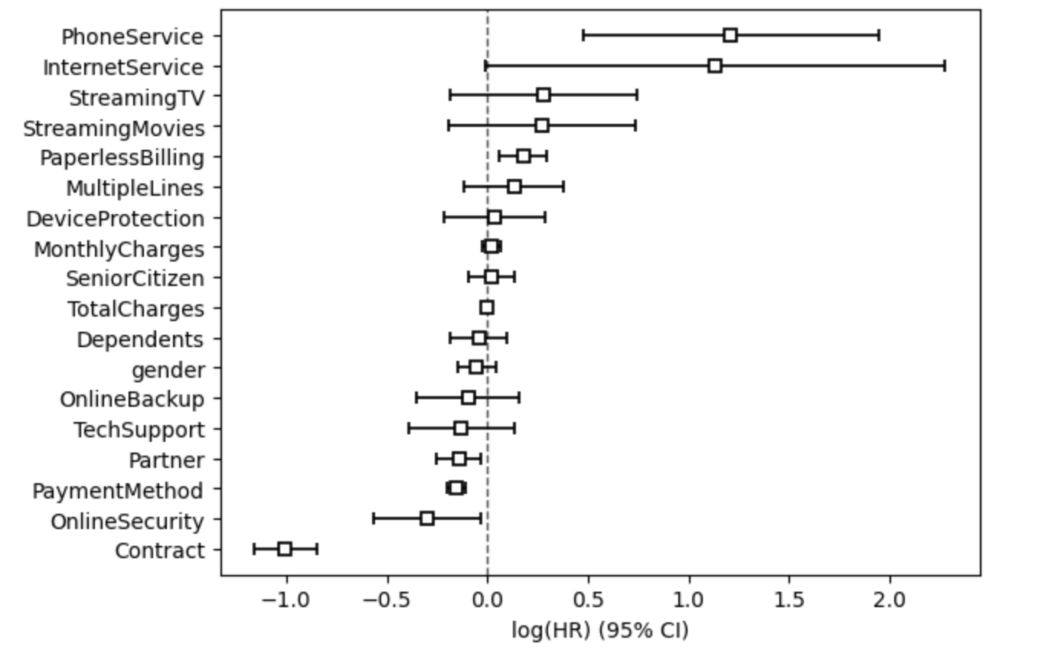

### **Log Hazard Ratios Plot**

* **Interpretation:**
  + Factors on the right (positive HR): Increase the likelihood of churn (e.g., Phone Service, Internet Service).
  + Factors on the left (negative HR): Decrease the likelihood of churn (e.g., Contract, Payment Method).
  + The confidence intervals (horizontal bars) show variability. Narrower bars indicate more reliable estimates.

### Recommendations:

1. **Focus Areas to Reduce Churn:**
   * Improve customer experience for **Phone Service** and **Internet Service** as they significantly impact churn.
   * Promote long-term contracts to reduce churn likelihood.
2. **Tailored Campaigns:**
   * Target housing-related customer segments, as "housing" appears as an influential variable.
   * Leverage data on "day" to predict and prevent churn patterns.
3. **Additional Analysis:**
   * Investigate less significant variables (e.g., gender) for potential indirect effects or interactions.